COMP 340  
Data Type  
Paul Kim

1. What is data type?
2. Why do we study data types?
3. Primitive Data Type
   1. Integer
   2. Floating Point
   3. Character
   4. Boolean
4. Composite Data Type
   1. Array
   2. Tuple
   3. Dictionary
   4. String
   5. Set
   6. Object (Class)
5. Variable Type
6. Explicit Variable Declaration
   1. Advantage
   2. Disadvantage
7. Implicit Variable Declaration
   1. Advantage
   2. Disadvantage
8. Type Checking
   1. When are types checked?
   2. How seriously are type-errors handled?
9. Static Type Checking
   1. At compiled time

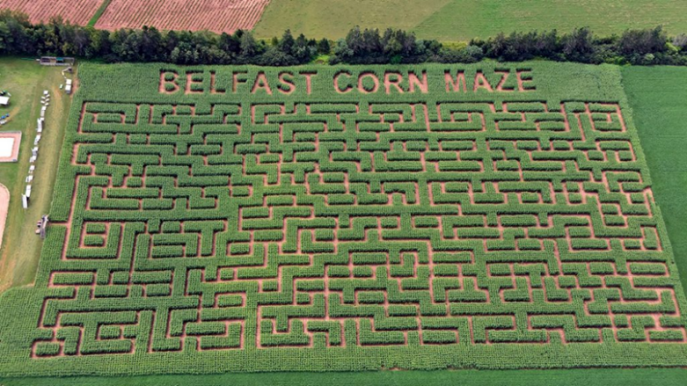

* 1. Variable type

1. Dynamic Type Checking
   1. During run time



* 1. Variable type
  2. Dynamic type checking vs implicit variable declaration

1. Static Typing vs Dynamic Typing
2. Strong Type Checking
3. Weak Type Checking
4. Strong Type Checking vs Weak Type Checking
5. Duck Typing
   1. Duck Test

“If it walks like a duck and it quacks like a duck, then it must be a duck”

|  |  |  |
| --- | --- | --- |
|  | Quack! |  |

* 1. In statically typed language,

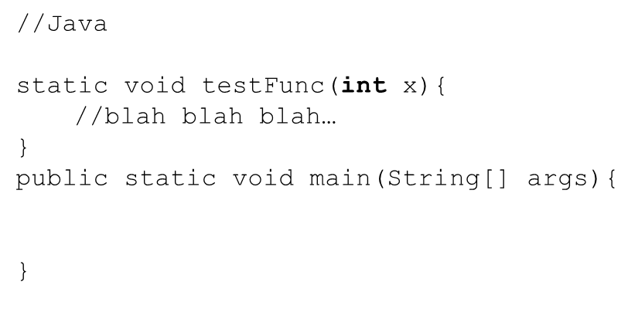

* 1. In dynamically typed language,

